Art / Exhibition

ROCK MY SOUL II (Stockholm)
Curator: Sir Isaac Julien
Exhibition producer: Ulrika Flink
Karlaplan 14, 2022.09.30 – 2022.11.27

In Eva Livijn's apartment at Karlaplan, one of the art world's big stars, Sir Isaac Julien, has given space to 25 female artists in an exhibition that touches.
There is an apartment on the ground floor of a grand house in one corner of Karlaplan on Östermalm in Stockholm. Gallerist Eva Livijn lives in the apartment, whose gallery has been integrated right there for a few years, in the apartment in the house on Karlaplan. Here, in recent years, in her home – bedroom, kitchen and toilet included – she has shown attention-grabbing and fantastic artists such as Swedish Natalie Djurberg and Hans Berg, Danish Jeannette Ehlers and Swedish Olle Norås.
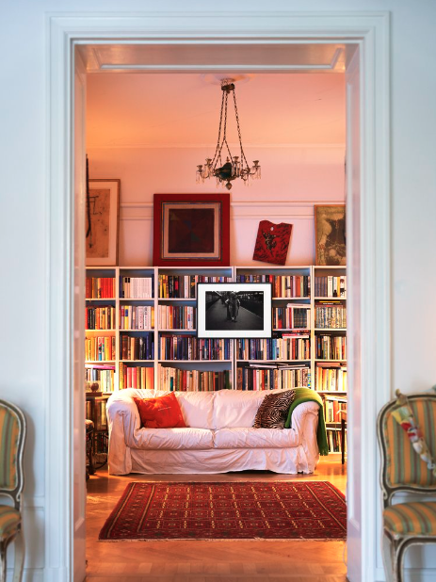
On September 30, it was time for a new exhibition to open, perhaps the most lavish and in many ways the most impressive to date. The exhibition Rock My Soul II (Stockholm) is a continuation of Rock My Soul , which was shown at the London-based art gallery Victoria Miro Gallery in autumn 2019. Rock My Soul was curated by Isaac Julien, who has been able to call himself Sir Isaac Julien for a short time now - he was recently knighted in his home country of Great Britain for his works in art. Julien, who is an artist, filmmaker, curator and professor, has gained international attention primarily for his films and video art installations, many of which deal with black and gay identity, issues of class, sexuality, artistic history and cultural history.
Isaac Julien and Eva Livijn have been friends for several years, and through Rock My Soul II (Stockholm) they, together with exhibition producer and program curator Ulrika Flink, provide space for 25 female and non-binary artists from the African diaspora at home in Livijn's apartment. The title of the exhibition is borrowed from a book by the American author, professor, feminist and political activist bell hooks – a book about self-esteem and self-esteem, about finding one's voice and breaking away from a legacy of devaluation. "Without self-esteem, one loses one's sense of meaning, purpose and power", she wrote, among other things, and it is based on that theme that the exhibition has been formed.
The artists are between 30 and 96 years old and several are international stars, including South African Zanele Muholi, Nigerian-American Njideka Akunyili Crosby and British Sonia Boyce, who won the Golden Lion at this year's Venice Biennale. From Sweden, Theresa Traore Dahlberg and Fatima Moallim participate, from the neighboring countries of Norway and Denmark, Frida Orupabo and Jeannette Ehlers stand out. Through their art, the artists raise questions about self-representation, about origin and gender, self-esteem and heritage, about the right to take a place and to be heard.
It is a touching, often strong and many times aesthetically beautiful exhibition that Julien, Livijn and Flink have put together. Rock My Soul II (Stockholm) is open until November 27, book an appointment for a visit by emailing: eva.livijn@futuragallery.se

Karolina Modig

